**Science Crime Busters:**

**The Case of the Missing Dog Biscuit Recipe**

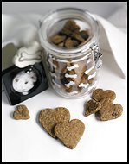

**The Crime:**

It has been known that *Moochies*, the Doggie Bakery, makes the best dog biscuits in town. Several attempts have been made to steal the famous recipe from the Doggie Bakery. The owner, Mr. Ruff, is extremely protective of his family recipe because it doesn’t contain any sugar. The recipe has been in the family for over 50 years. Mr. Ruff has three employees who work for him at the bakery. On January 14, 2011, Mr. Ruff received an urgent phone from a female caller to return home. Mr. Ruff left the bakery in a hurry and returned the famous Dog Biscuit Recipe back into the combination lock vault but forgot to close it! When he returned the recipe was gone! He immediately contacted the Arizona Police Department to help recover the family recipe.

**The Evidence:**

You have been asked to help the Arizona Detectives to identify the dog biscuit recipe culprit. Evidence gathered at the scene includes:

1. Fingerprints on the combination lock vault
2. Shoeprints found by the vault
3. Powder residues on the floor next to the vault where the recipe was stored
4. Hairs found clinging to the vault
5. Mud spatter located in the alley directly behind the bakery
6. Liquid residues on the baking counter and vault

**The Suspects:**

**Miss Kitty** assists Mr. Ruff in making the famous dog biscuits. She wants to start her own dog biscuit bakery and has been thinking about opening up a store. She wears expensive linen suits to work. She owns a cat named, Bob.

**Mr. Hairball** despises making dog biscuits. He hates dogs, but needs this job to feed his family. He owns a Bloodhound dog named George to keep his kids happy. Mr. Hairball loves to salt his food even his cereal and carries a salt shaker wherever he goes!

**Mrs. Beagle** has worked for Mr. Ruff for many years. She aspires to be the best dog biscuit baker ever! She has told Miss Kitty about her dream of being a dog biscuit baker. Mrs. Beagle loves to eat strawberries with lots and lots of sugar and she wears a red cotton shirt when she eats strawberries.

**Mrs. Busy Body** lives 60 miles from *Moochies* on a lemon farm. She hates the long drive to the bakery and has asked Mr. Ruff for the biscuit recipe several times. She loves to eat hot peppers, but can only eat them if she takes Alka-Seltzer®. She buys the doggie biscuits for her beautifully groomed Wheaton dog named Nadia.

**Ms. Foxhound** is Miss Kitty’s sister. She hates that Miss Kitty works late and also needs Alka-Seltzer® to calm her stomach. She wishes that the Doggie Bakery would go out of business. She would like Miss Kitty to come work for her because she owns a window washing business. On the day in question, she had asked Mr. Ruff for ammonia and a sponge to clean his windows for free.

**Dr. Chase** owns a dog, called Bode, a golden collie. Dr. Chase takes Vitamin C every day because it makes him feel better. Bode loves Mr. Ruff’s dog biscuits and Dr. Chase has been after Mr. Ruff for the recipe for years. Mr. Ruff refuses to give Dr. Chase the recipe and Mr. Ruff has even caught Dr. Chase snooping around the bakery.

**Science Crime Busters: The Case of the Missing Dog Biscuit Recipe, Written Analysis, Page 3**

**9. WRITTEN ANALYSIS: (Section worth 22 points total)**

Answer the following below. Based on the evidence gathered, identify which suspect committed the crime and who didn’t commit the crime. Explain how you came to your conclusions. Be creative, demonstrate critical thinking, and use some sound logic and reasoning to support conclusions.

**Science Crime Busters: The Case of the Missing Dog Biscuit Recipe**

**Suspects’ Fingerprints**

**Suspects’ Shoeprints**

**Science Crime Busters: The Case of the Missing Dog Biscuit Recipe**

**Evidence Found at the Scene**

**3. Shoeprints**

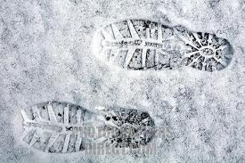 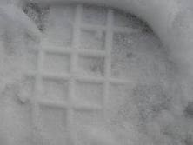

1. **(B)**

**4. Fingerprints**

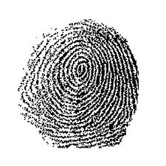 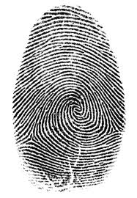

1. **(B)**

**Science Crime Busters: The Case of the Missing Dog Biscuit Recipe, Written Analysis, Page 3**

**ANSWER KEY - WRITTEN ANALYSIS: (Section worth 22 points total)**

Answer the following below. Based on the evidence gathered, identify which suspect committed the crime and who didn’t commit the crime. Explain how you came to your conclusions.

It appears Mrs. Busy Body and Dr. Chase were partners in this crime. **(4 points)**

Both have dogs and evidence found at the scene. **(4 points)**

Mrs. Busy Body owns a lemon farm. Lemon juice found at the crime scene. **(2 points)**

Mrs. Busy Body takes Alka Seltzer and it was found at the crime scene. **(2 points)**

Dr. Chase takes Vitamin C. Vitamin C found at the crime scene. **(2 points)**

Both Mrs. Busy Body and Dr. Chase’s shoeprints **(2 points)** and fingerprints **(2 points)** found at the scene.

Too little evidence gathered at the scene to point to Miss Kitty, Mr. Hairball, Mrs. Beagle and Ms. Foxhound. **(4 points)**

**If they mention that Mrs. Busy Body could have been the female caller that is worth 1 point as bonus.**